Toy final presentation 「Ultrasonic sensor’s timer」

Environment information

grade 4

Masashi Wakita

71748760

source code

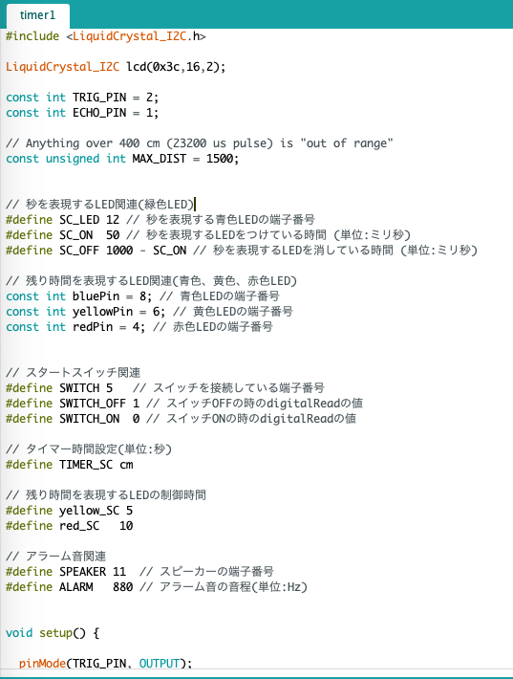



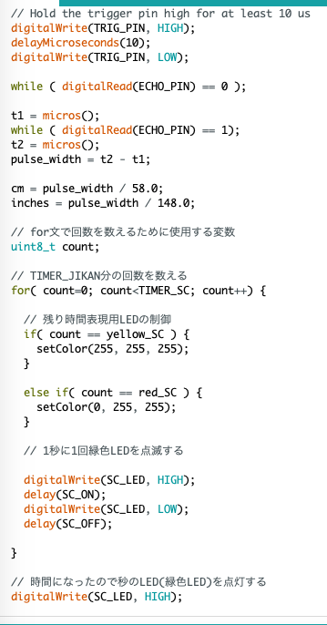

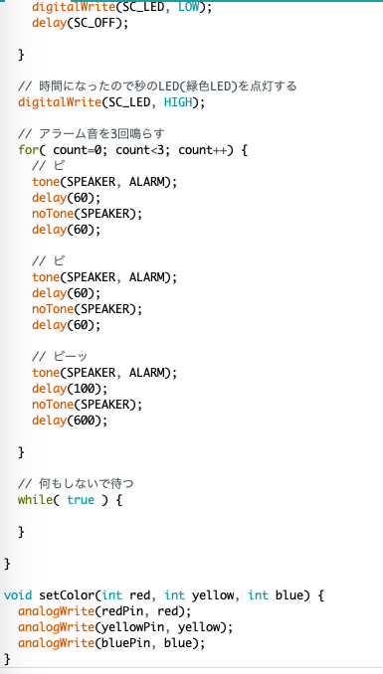

outcome

・We can deal with quantitative time as intuitive time. We can add time by the distance between the wall and the timer if I couldn’t make time it in time.

For example, I can handle remaining time as 1.5 times by changing the distance of 1.5 times.

・This prototype timer can use as kitchen timer if it is applied.

TASK

・I tried to turn on LCD screen by every means, but I couldn’t turn on it.

・It is difficult to control Ultrasonic sensor’s distance.

When I turn on only LED’s red color, I couldn’t turn on it. Maybe it occurs by complicated source code or cable arrangement.